Feedback:

Tenant Registration - Fleming Lettings
The tenant registration form on the above link is not allowing the user to submit. It comes up with the below error message:
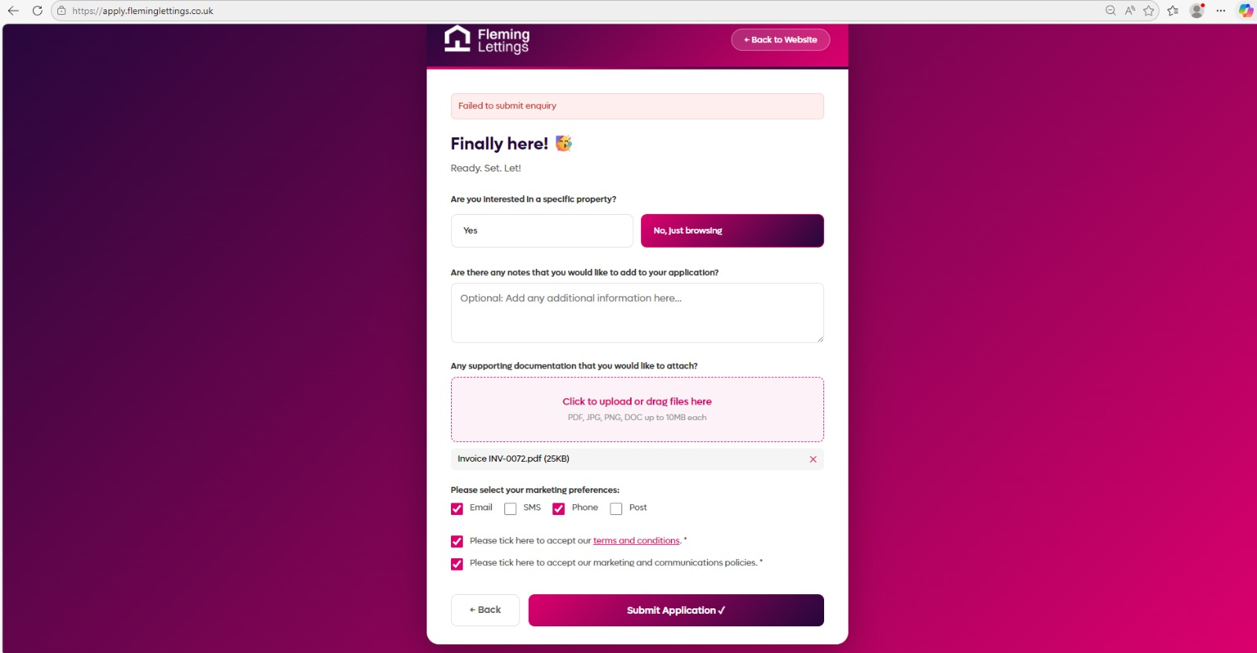

Also, when the user clicks Yes under ‘Are you interested in a specific property?’ the searchable pre-populated box with all un-tenanted listed properties no longer appears. The screen goes grey and no options appear until the user clicks off the screen. Please fix.

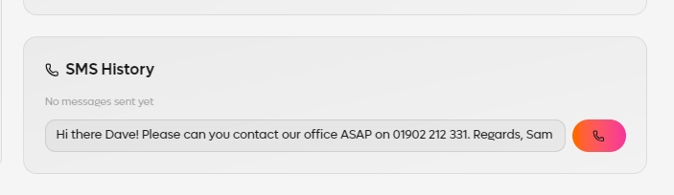
SMS module section on the pages – when the user types more than a line of text the text box needs to expand (down) so the user can see the whole message.
The action/send button on the right also needs to be changed to a message icon or a ‘Send’ message button. All sent SMSs should then show under the box with a timestamp and a ‘delivered/pending/rejected’ mark from the results given from the SMS Twillo account.
This also needs to be linked and working via our Twillo account:
Twillo account:
accounts@fleminglettings.co.uk
Password: Test123779//

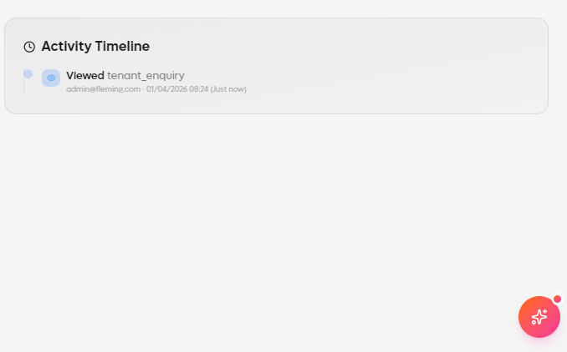
Activity timeline needs to track ALL activity on the record, including: page views, edits, document uploads, SMSs being sent out, onboarding process updates, notes being left on a record and any progression/rejections. It needs to show the user ID, time and date.

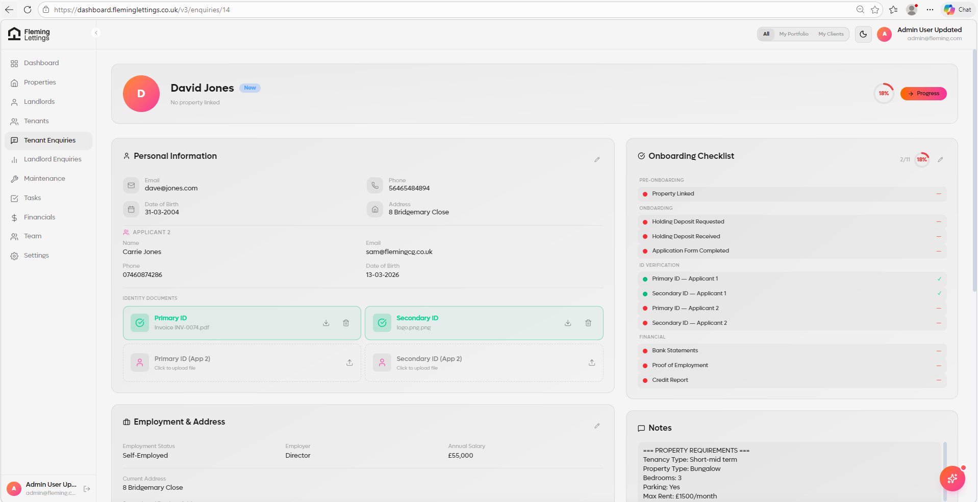
On a tenant enquiry page there is currently no way of linking the record to a property. We need a clear section/box that allows the user to search and select a property that this record should belong to.
The property record itself should NOT show this tenant enquiry record as a linked tenant until the record has been converted and fully onboarded.

On a joint tenant enquiry application, it does not allow the user to add documents for the second applicant (applicant 2). Nothing happens when a document is added.
Although, the joint applicant should have its OWN individual tenant enquiry record themselves and be interlinked as they are joint. For example, when converted and onboarded to a ‘tenant’ both tenants will show as individual linked records under the property page > tenants.


At present the CRM seems very glitchy across pages, including ‘Progress’ screen, the boxes keep on jump and not allowing the user to select and option. Please investigate and fix.

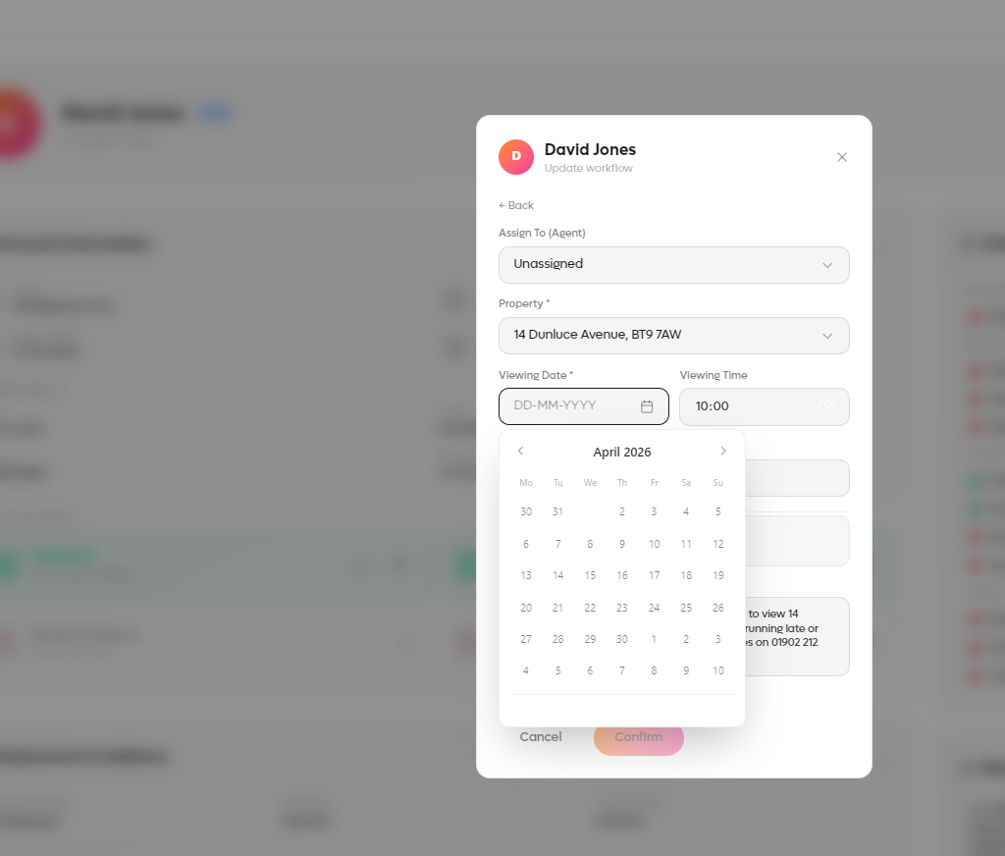
On light mode, the selected date you cannot see. Please make sure it shows which date has been selected.

When booking in a viewing on a tenant enquiry record it seems to take a very long time to progress once the user has selected ‘Submit’ – i.e. its running very slow. Can you investigate and see why this is taking so long?

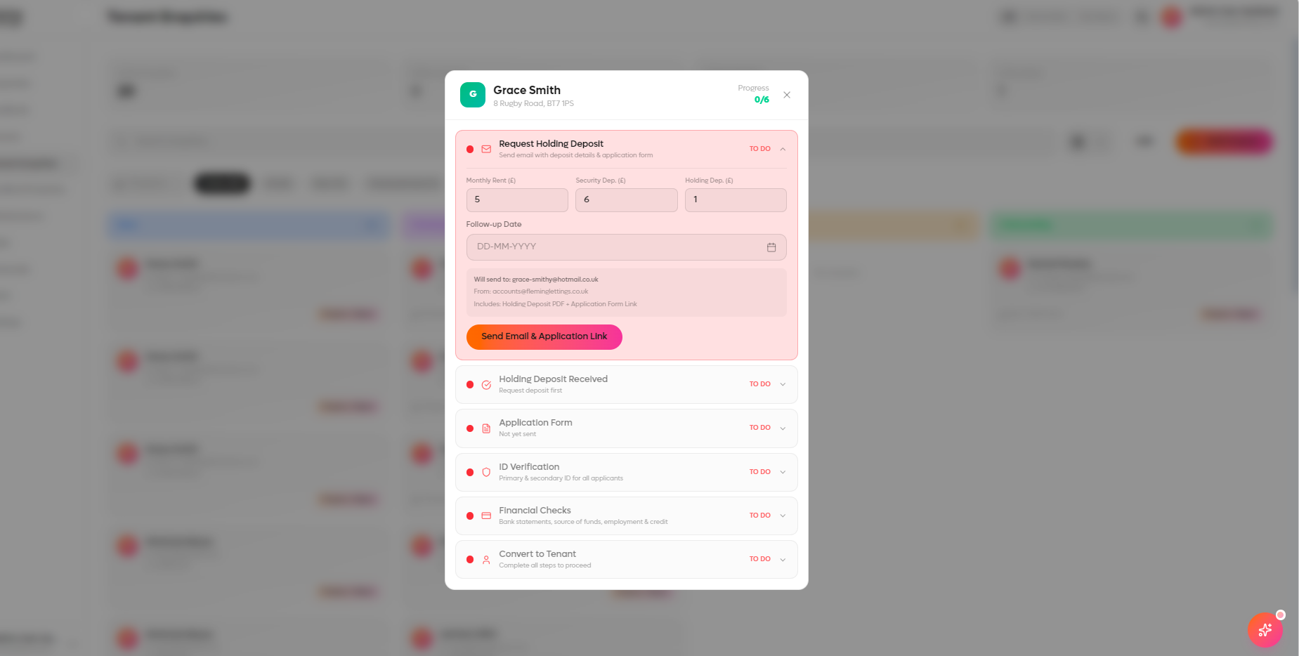
When progressing an onboarding, the request holding deposit section – it does not allow the user freetext (numeric) when typing. For example the user can only type one number in at a time. Please change this so it allows the user to enter as many number in as they want when editing. The security deposit should also NOT pre-populate.

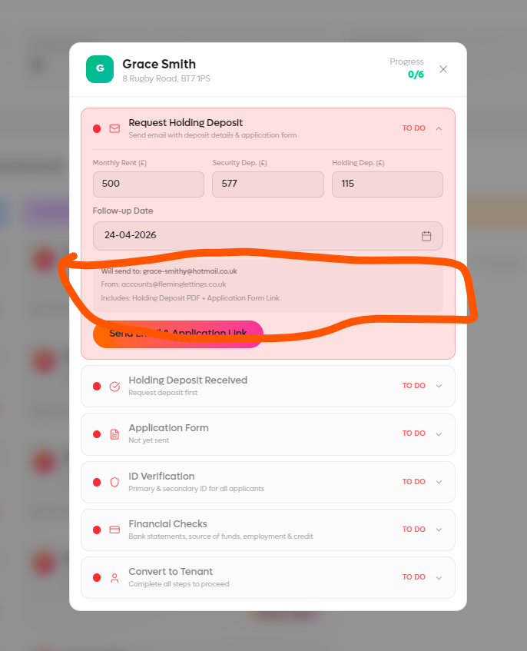
With the preview section we need to see the body of the email and allow the user to edit it as it allows in the SMS functionality of the CRM. Again, the content and subject is noted below and this is what the user should be seeing (I have highlight in yellow the editable and pre-populated fields that should be generated):
SUBJECT: Tenancy Application – PropertyAddress
CONTENT:
Dear FirsName,

We are delighted you wish to book the property at PropertyAdrress.

To confirm the specifics are noted below:

Rent: £MonthlyRentAmount per calendar month (due on the anniversary of the tenancy start each calendar month).
Deposit: £SecurityDepositAmount to be protected in a government-approved deposit scheme of the landlord’s choice.

The property is immediately available, and we would like the tenancy to begin as early as possible. The latest commencement start date we can allow is the Pre-populate a date here two weeks from the date of issue – i.e. 15th April 2026 as per the instruction from the landlord. Please can you click here to complete and sign your tenancy application form: Populate the unique application from link here- note that the form needs to allow joint applications and two signing boxes.

We require a holding deposit of £HoldingDepositAmount to reserve the property. This is not a fee, and this will be deducted from your first initial rental payment. Please note that payment of the holding deposit does not guarantee your tenancy or approved application with us. The application process is subject to numerous checks and criteria.

Credit checks will be conducted on all applicants and receipt of your security deposit and completion of the above application form, is acceptance of your understanding that these will be done as part of the application process. The balance will need to be paid on or before the agreed date for the key handover.

Please can you both also provide us with the below documentation along with your completed application forms:
- Current landlord reference.
- Last three months’ wage slips for all tenants. If self-employed, please provide us with CIS statements for the past two years and a letter from your accountant confirming profit.
- Employment reference from your employer’s HR department. This can be on formal letterhead addressed to us or via email communication to enquiries@fleminglettings.co.uk, or alternatively please confirm your line manager and/or HR departments email address and your employee ID for us to contact them directly.
- Last three months’ bank statements for each applicant.
- Photo ID - scanned copies of your passports.
- Address ID - Scanned copies of your driving licences and/or three months utility bills or current council tax statement.

Please note that we require all of the completed documentation and forms back within 5 working days. Failure to do so may result in your application being rejected and forfeiture of your holding deposit.

The bank details for the holding deposit are noted below:

Sort Code: 20-08-64
Account Number: 03803880
Account Name: Fleming Lettings and Developments UK Limited
Bank Name: Barclays Bank PLC

Please can you provide email or telephone confirmation once you have paid the holding deposit.

If you have any questions, please don’t hesitate to contact either ourselves or Marie.

Kind Regards,
Accounts Team

Lettings Support Team | fleminglettings.co.uk | accounts@fleminglettings.co.uk | 01902 212 415



This email and its attachments may be confidential and are intended solely for the use of the intended recipient. If you are not the intended recipient of this email and its attachments, you must take no further action.
Fleming Lettings is a trading name of Fleming Lettings & Development UK Ltd. Company Number 13943597.

Application form that goes out to the tenant feedback (via the unique link):
This needs optimising for mobile and tablet.
The logo is also not showing. Please ensure it looks exactly how it does on the tenant application form, shown below:
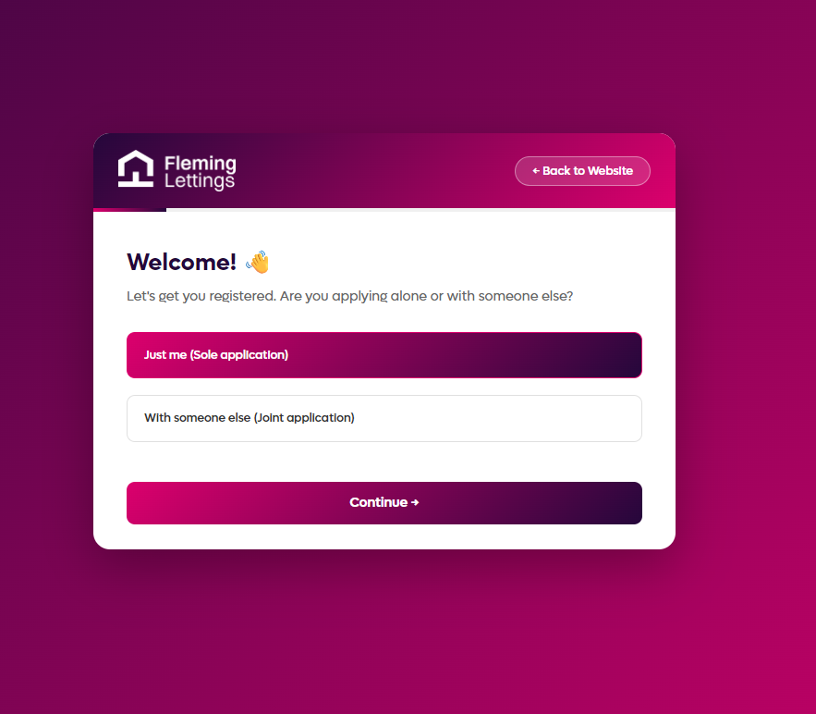

The fonts, boxes, styles and formatting of the tenant application form also need to look like they do on the below: (click here: Tenant Registration - Fleming Lettings)
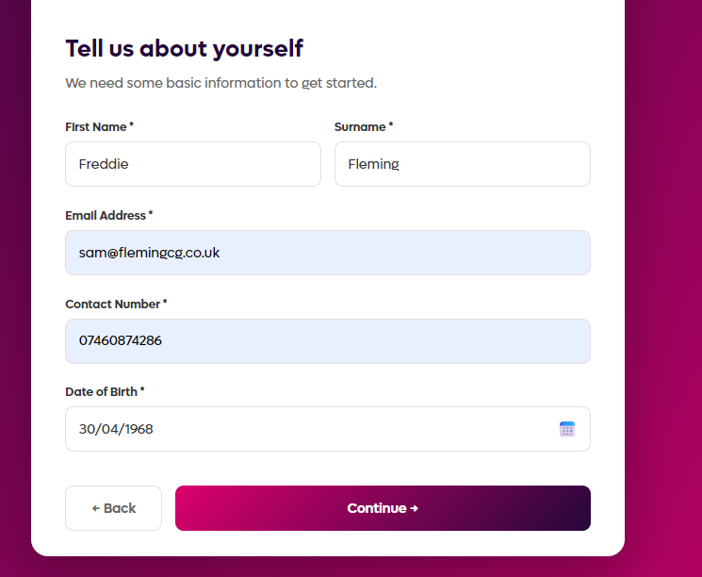

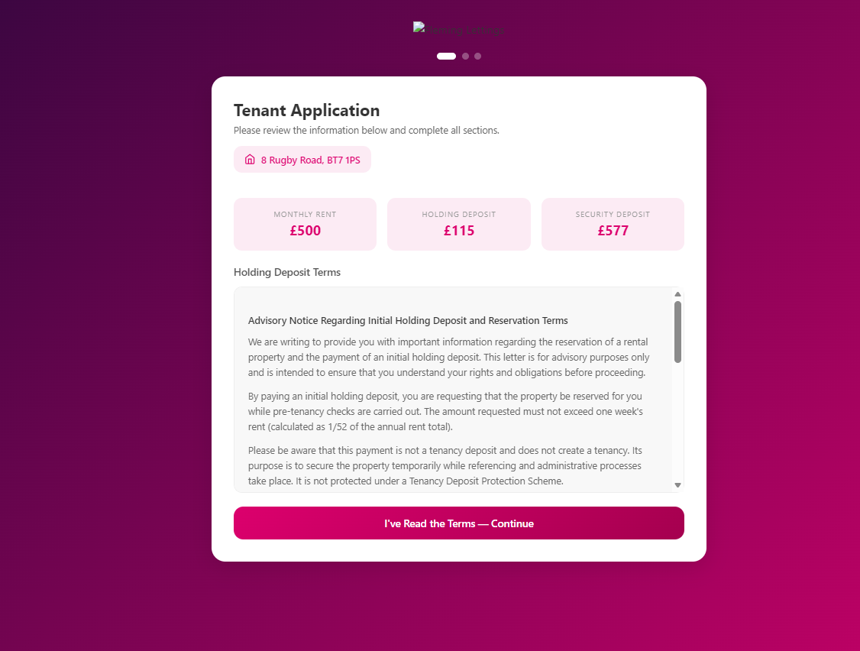
Top header should say: Your tenancy application form.

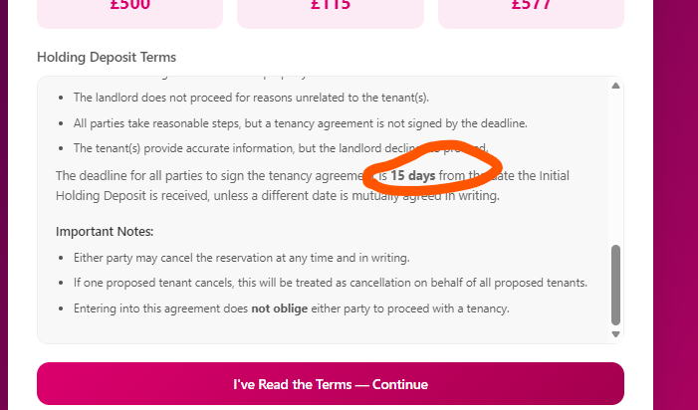
This should say 14 days.


The action box should say: ‘I’ve read and agree to the Terms & Conditions – Continue’

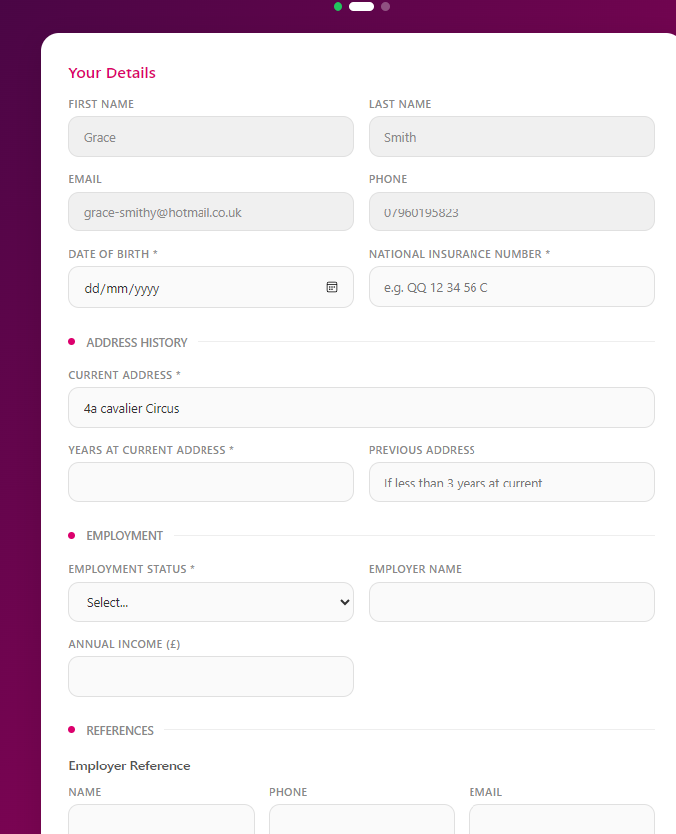
Some of the information has pre-populated which is good; but it does need to allow the user to edit it – can we have an edit icon next to each pre-populated box to allow the user to click it and then edit it should they need to.
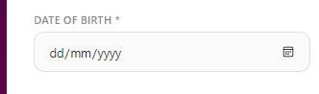
Please ensure pre-populated text here shows as DD/MM/YYYY. Also please ensure that the icon looks like it does on the other application forms, shown below:
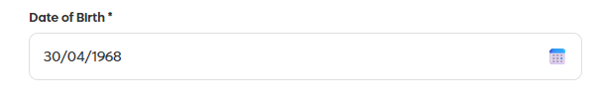

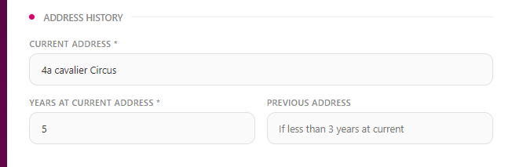
When the user starts typing within the box i.e. ‘4a’ it should start pre-populating the address via a lookup like it would do on Google.
Please remove previous address box. Instead, it should allow the user to select ‘Add a previous address’. And again, the same fields should pre-populate such as Years at address and full address.

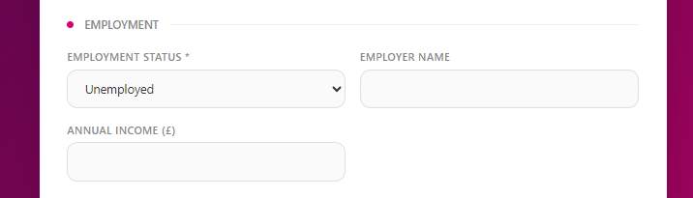
When the user clicks ‘unemployed’ then the employer name should not be showing.
This section should be called Employment Information’.
Please ensure that the following fields show when the user clicks ‘employed’:
Employers Name
Employers Address
Employers Contact Number
Years of Service - (this to be a freetext box)
Pay Frequency – (this to have the options: Weekly, Fortnightly, Monthly, Other).
Annual Salary (£)
Any Other Income (£)
Please ensure that the following fields show when the user clicks ‘self employed’:
Employers Name
Employers Address
Employers Contact Number
Number of Tax Years Employed - (this to be a freetext box)
Pay Frequency – (this to have the options: Weekly, Fortnightly, Monthly, Other).
Annual Salary (£)
Any Other Income (£)
-
For any other option such as unemployed, student or retired – it needs to show ‘Annual Income (£).

References section needs checkbox options saying ‘Do you have an employers reference?’ and ‘Do you have a previous landlord reference’ – options yes and no. if yes, the below populates with boxes.
Employer reference box options needs to be:
Name or Department
Contact Number
Email Address
Your Employee ID/Reference
Previous Landlord Reference options:
Landlord Name or Department
Contact Number
Email Address
Property Address/Reference Number

IMPORTANT – each one needs to have checkboxes (maybe a yes and no) with a disclaimer on them for the user to mandatory tick to agree that we can contact their reference for a reference. For example: Please confirm if we can contact this reference?
Next of Kind section needs to include the following:
Name:

Address:

Contact number:

Relationship to you:

Name:

Address:

Contact number:

Relationship to you:

We also need to add a free-text box at the bottom of the form saying: Is there any further information that you would like to submit as part of your application?

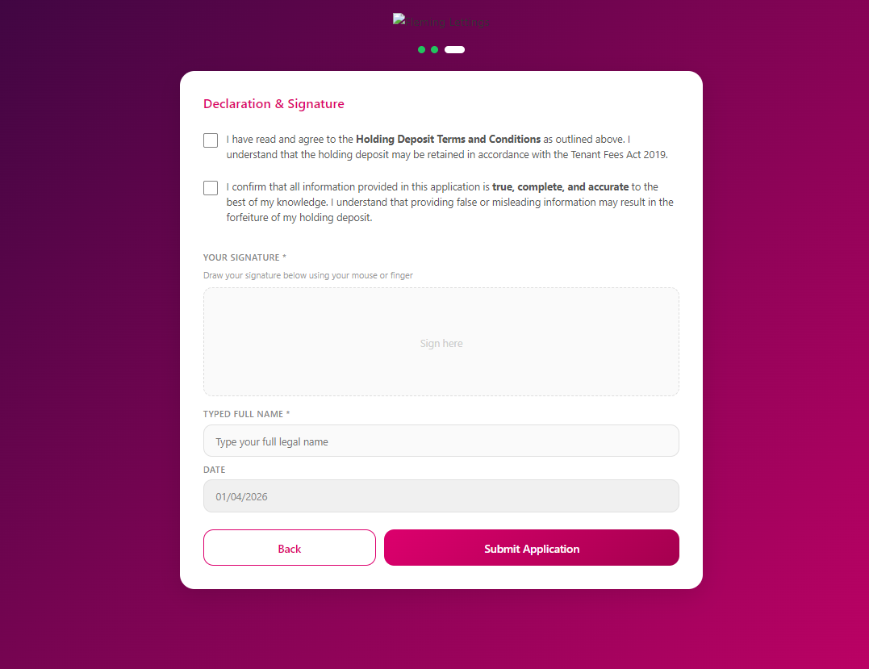
Declaration and Signature needs the following tick boxes:

I have read and agree to the Holding Deposit Terms and Conditions as outlined on the correspondence that has been issued to me. I understand that the holding deposit may be retained in accordance with the Tenant Fees Act 2019.

I confirm that the information supplied by me in this application is true and complete to the best of my knowledge and I understand that providing false or misleading information may lead to my application being refused.

I understand that the information provided here will be retained and used only as necessary and for a specific purpose in accordance with the General Data Protection Regulation (GDPR) as set out in the privacy notice supplied by the Landlord/Agent.

I authorise my employer, my bank/building society, a local authority (if I was previously a council tenant), current or former landlord, and the any personal referee named, to provide information about me, any prior tenancy history, and any employment / financial affairs as appropriate to the Landlord's enquiries.

If I am making a tenancy application, I consent to receiving my copy of ‘How to rent: a checklist for renting in England’, the energy performance certificate (EPC), gas safety certificate, electrical installation condition report (EICR) or any other documentation relating to the proposed tenancy via the given email address on page 1.

I authorise the Landlord/Agent named at the beginning of this application form to make whatever enquiries, including a credit check, they deem necessary in connection with this application.

I consent to a credit check being carried out in relation to myself which will be conducted on the Landlord/Agent’s behalf by: Fleming Lettings & Developments UK Limited.

Please tick here to accept our Terms and Conditions. *

Please tick here to accept our marketing and communications policies. *

 submit button and back button need to mirror the formatting above as per the tenant registration form (Tenant Registration - Fleming Lettings).

When an onboarding stage has been completed it does not allow the user to click on the drop down to see the specifics when it should do. For example, I should be able to click the drop down on the Application Form now and it show me the completed PDF of the application form that was just done by the tenant. See below:
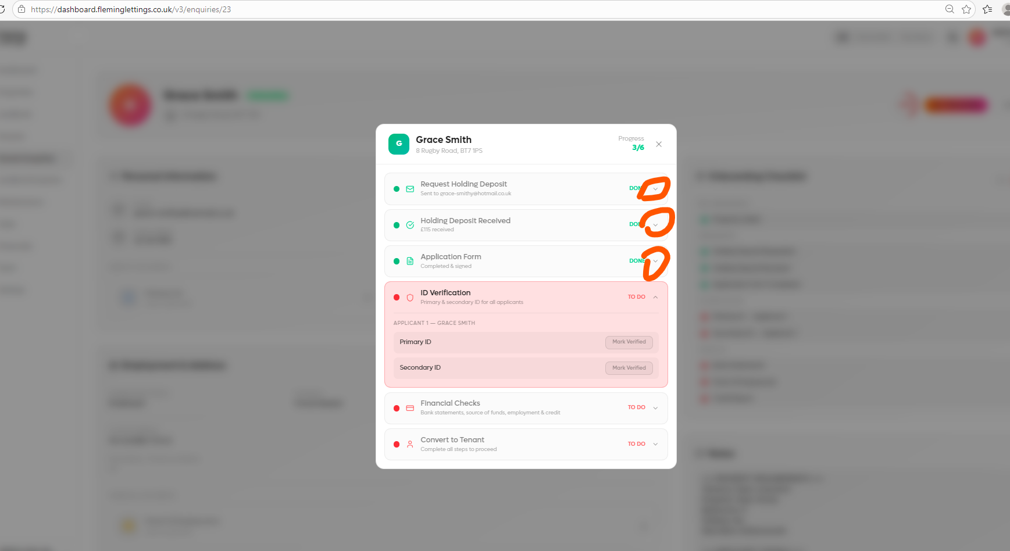

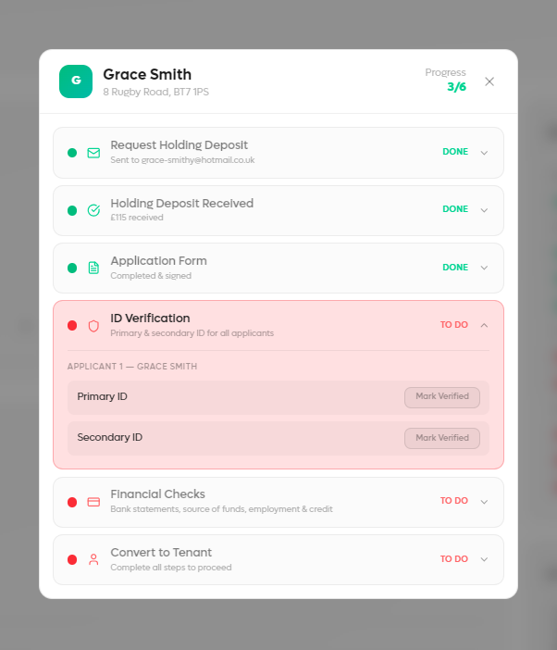
The ID Verification section should allow the user to upload the document directly via the onboarding screen and it currently does not.

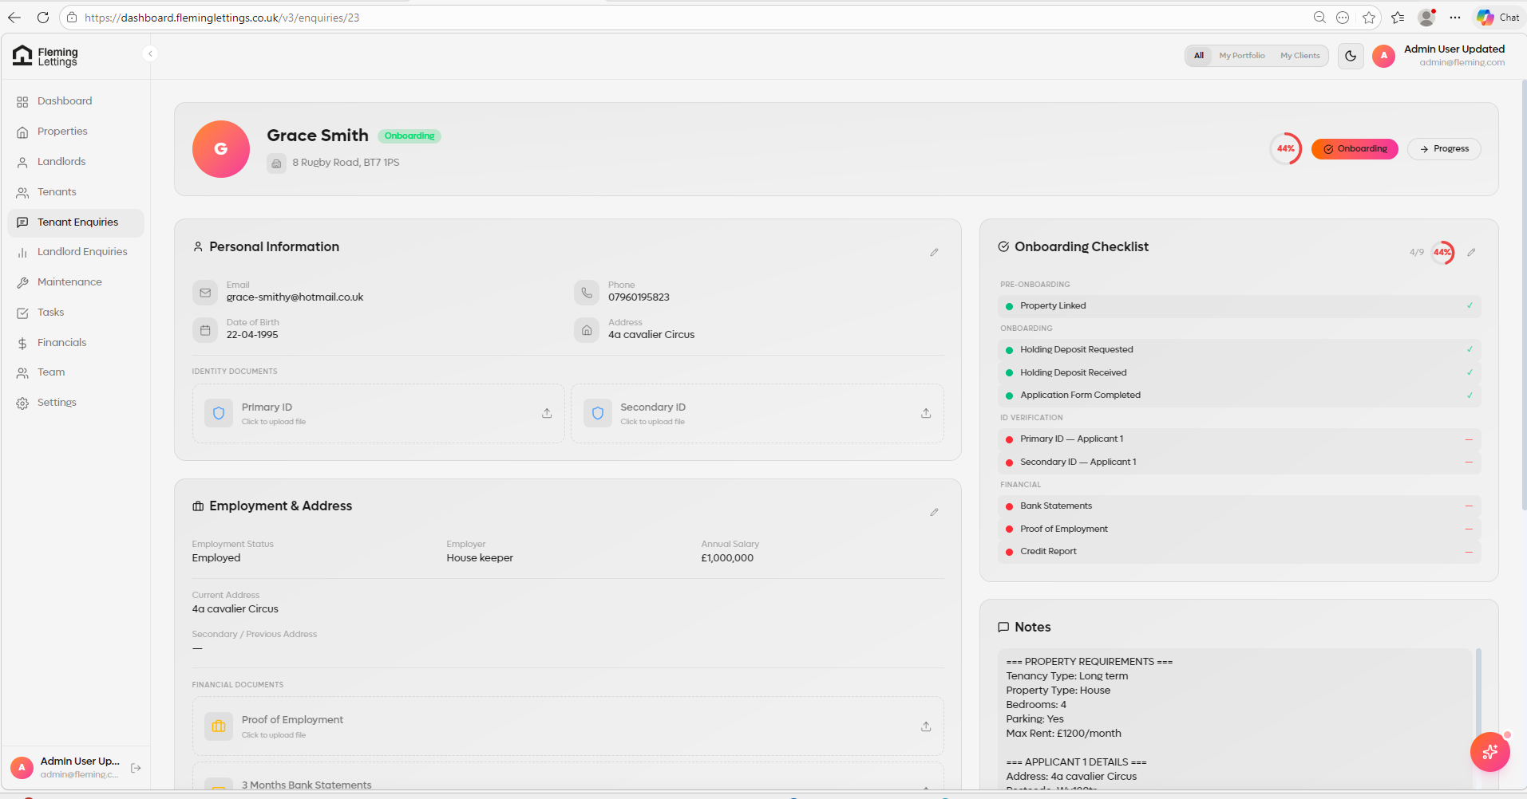

All of the information that was completed and added/attested too on the tenant application form should now pre-populate and override all personal information/employment information within the tenant enquiry record.

__
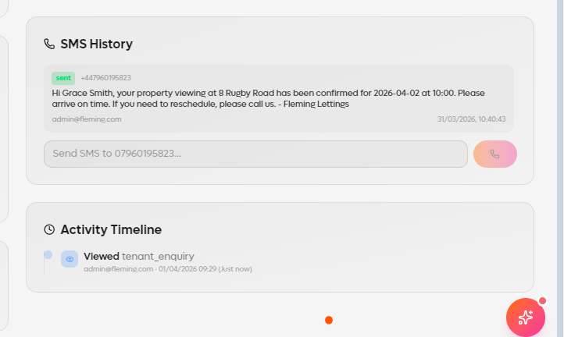
The activity timeline should also state that the user has ‘clicked on the link’ and ‘completed the application form’ with a time and date stamp.

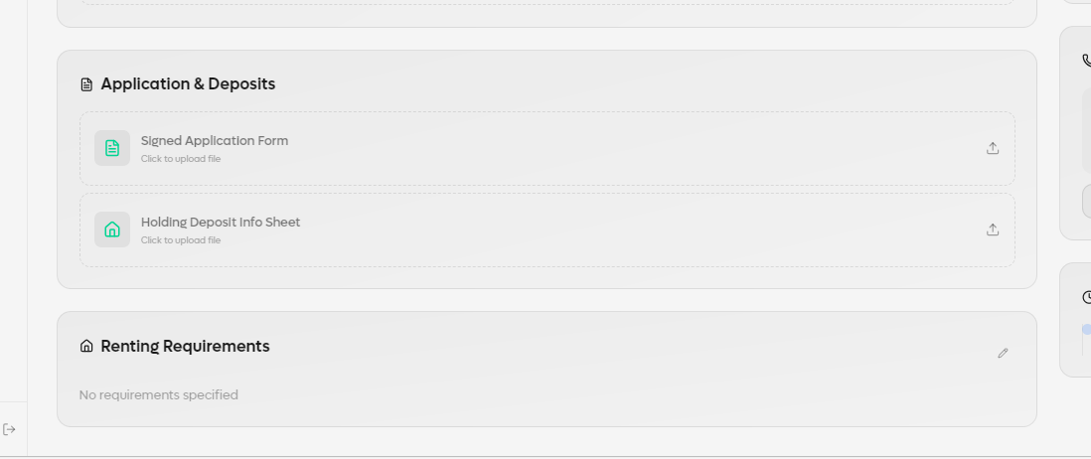
The application for and holding deposits should NOT be a document upload section – instead this should be a tracking section, showing the progress of the signed application form from the unique link that was sent – i.e. ‘Waiting on Tenant to complete’. And holding deposit request should show the date and email plus attachments that were sent, along with a box ‘Date Deposit Received’ box that would source the information from the onboarding checklist itself. Shown below:
